Explain logic of field [Status] -> [HeaderComponent]:
1. When can it be changed and when it cannot, what does it affect?
-----
Ziel 1, Ziel 2 -> How many is required
-----

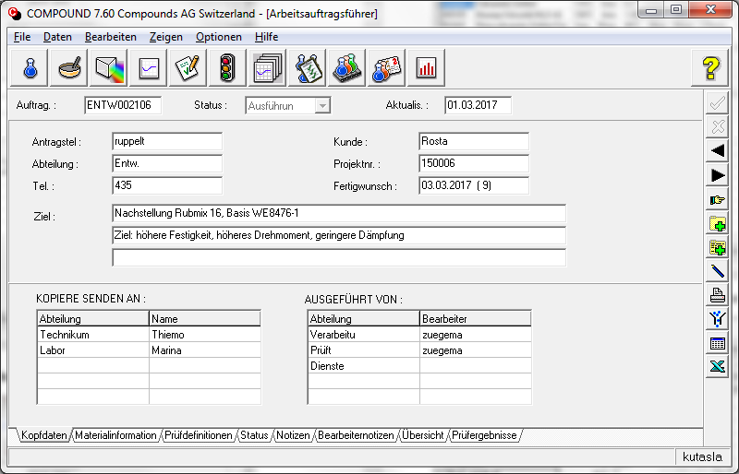

Explaing fields "Notizen" (ComboBoxes)
-----
Eplain fields "Code" (Not delayed)

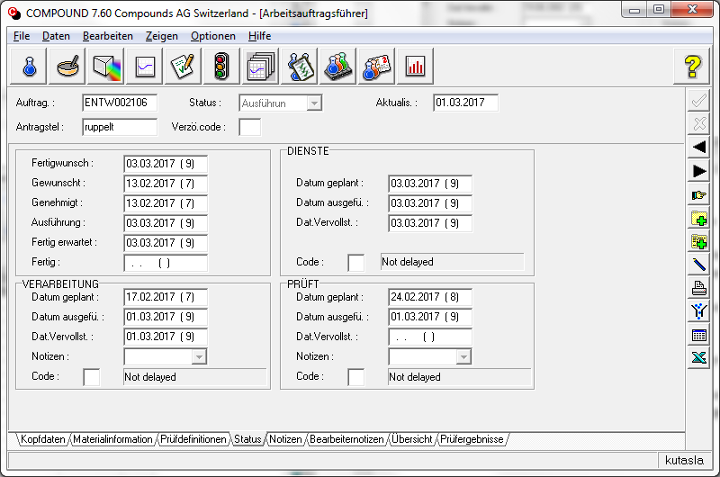

"Beshreib.", "Mischer" -> where does it come from

